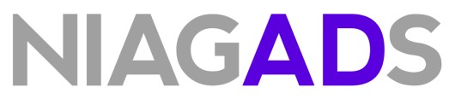
CODE OF CONDUCT

The code of conduct for the use of data that are stored at NIAGADS is as follows:

Approved users of research data obtained from NIAGADS agree to abide by the Code of Conduct. Failure to abide by any term within this Code of Conduct may result in revocation of approved access to any or all datasets obtained through NIAGADS.

1. Investigator(s) will use requested datasets solely in connection with the research project described in the approved Data Access Request for each dataset;
2. Investigator(s) will ensure that any employees, representatives or other parties approved for use of the datasets comply with the terms and conditions of this Agreement;
3. Investigator(s) will make no attempt to identify or contact individual participants from whom these data were collected without appropriate approvals from the relevant IRBs;
4. Investigator(s) will not distribute these data to any entity or individual beyond those specified in the approved data access request or as otherwise required by law;
5. Investigator(s) will adhere to physical and computer security practices that ensure that only authorized individuals can gain access to data files or printed data as well as the actions described in the dbGaP Security Best Practices Requirements;
6. Investigator(s) will not submit for publication or any other form of public dissemination
analyses or other reports on work using or referencing NIH datasets prior to the embargo release date listed for the dataset (or dataset version) on NIAGADS;
7. Investigator(s) acknowledge the Intellectual Property Policies as specified in the
NIAGADS Data Distribution Agreement;
8. Investigator(s) will report to the Principal Investigator of NIAGADS any inadvertent data release or unapproved use in accordance with the terms in the NIAGADS Data Distribution Agreement breach of data security, or other data management incidents contrary to the terms of access immediately upon discovery of the breach; and
9. User(s) of the data generated by the Alzheimer’s Disease Sequencing Project (ADSP) will
withhold publication until the producers of the data have published their findings.

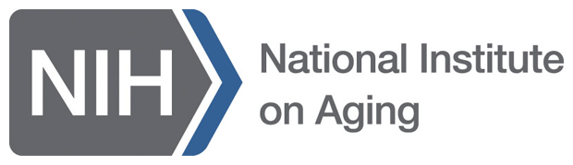
NIAGADS Code Of Conduct Page 2 of 2
Last Update: 7/29/26

